**BRIGHT FUTURE BWEBAJJA SECONDARY SCHOOL**

**END OF TERM II EXAMINATIONS 2023**

|  |  |  |
| --- | --- | --- |
| A |  | Total |
| B |  |  |

**S.1PHYSICS**

**For teachers use only**

**PAPER 1**

**TIME: 1½ HOURS**

**INSTRUCTIONS:**

-Answer **all** questions

-Be neat

1. Abdul looked at Jane and concluded that she was having a height of 2m. When he used a certain instrument to measure Jane’s height, he found out that Jane was 2.5m tall.

(a)Which physics name is given to the value?

(i) 2m as told by Abdul before using the instrument (½mark)

………………………………………………………………………………………………………………………………………………………………………………

(ii) 2.5m after using the instrument (½mark)

………………………………………………………………………………………………………………………………………………………………………………

(b)Why do you think there is a difference in the value? (1mark)

………………………………………………………………………………………………………………………………………………………………………………

(c)Which instrument do you think Abdul used (½mark?)

………………………………………………………………………………………………………………………………………………………………………………

(d)If the records from the hospital show that the true height of Jane is 3.0m.

(i)What is the difference between Abduls value (got after measuring) from what the hospital is having (1mark)

………………………………………………………………………………………………………………………………………………………………………………

(ii)State the physics used to mean the difference got in d(i) (½mark)

………………………………………………………………………………………………………………………………………………………………………………

(iii)Give one reason to why Abdul’s value was different from the true value.

(1mark)

………………………………………………………………………………………………………………………………………………………………………………

1. Appreciate the physics. The pictures below shows different activities (careers) you are required to study it carefully and answer the questions that follow.

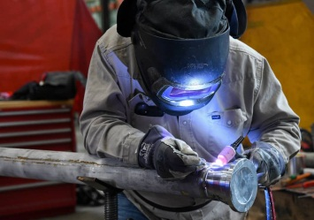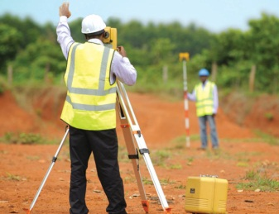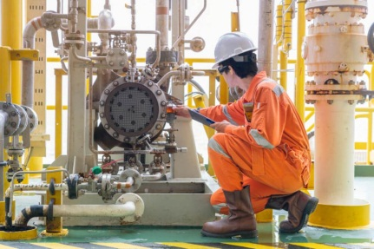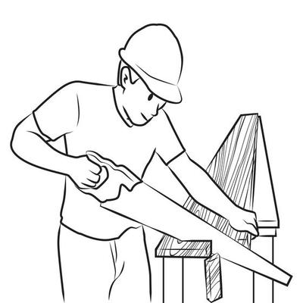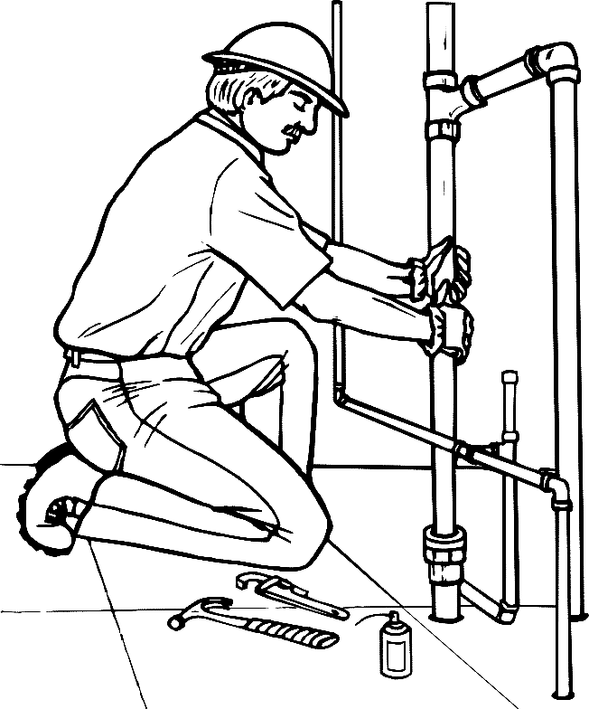

(a)In the table below, you are required to give the branch of physics and the corresponding careers/ activities from the pictures above.

|  |  |  |
| --- | --- | --- |
|  | Activity/ Career | Branch |
| 1 |  |  |
| 2 |  |  |
| 3 |  |  |

(3marks)

(b)So far from the topics you have studied, give one career that requires the knowledge from those topics

**Topic:**

Employment:

……………………………………………………………………………………………………………………………………………………………………………..

(c)What do you understood, by the word physics laboratory? (1mark)

………………………………………………………………………………………………………………………………………………………………………………

1. The figure below, shows Mr. Kikaaya’s house floor (living room). He is required to tile it but he doesn’t know the exact number of Box of tiles required.

From the hardware shop

Apiece of tile is 1 square metre

Each box has 12 tiles

(i)Calculate the number of tiles required by Mr. Kikaaya. (4marks)

………………………………………………………………………………………………………………………………………………………………………………………………………………………………………………………………………………………………………………………………………………………………

(ii)Which physical quantity is associated with the above scenario (1mark)

………………………………………………………………………………………………………………………………………………………………………………

1. “Matter is made up of smallest particles. Indifferent forms these particles move faster, slower and in the other form they don’t move. The particles are attracted to each other by a certain force of attraction. If the smallest particles are joined, a molecule is formed. If the temperature is increased or lowered, these particles are affected” that was the presentation made by senior one student during a physics symposium that took place at Bright Future Bwebajja secondary school. The above

(i)What name is given to the theory, the presentation is about (½mark)

………………………………………………………………………………………………………………………………………………………………………………

(ii)What is the name of the smallest particles (½mark)

………………………………………………………………………………………………………………………………………………………………………………

(iii)Which state of matter do these smallest particles

(a)move faster………………………………………………………….(½mark)

(b)move slowly………………………………………………………...(½mark)

(c)Don’t move…………………………………………………………(½mark)

(iv)If three particles in the state you have given in ii(c) don’t move, what do they

do? (½mark)

……………………………………………………………………………………………………………………………………………………………………………...

(v)Give what happens to particles if the temperature is increased (1mark)

………………………………………………………………………………………………………………………………………………………………………………

(vi)What name is given to the forces of attraction which hold these particles

together (1mark)

………………………………………………………………………………………………………………………………………………………………………………

1. Below is a ferry on lake victoria

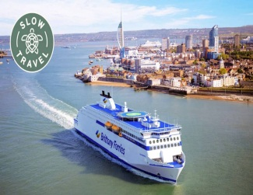

(a)A ferry is made up of steel which is more dense than water and therefore it’s expected to sink. But surprisingly it is able to float on water.

Give a reason why that is able to happen (3marks)

………………………………………………………………………………………………………………………………………………………………………………………………………………………………………………………………………………………………………………………………………………………………

(b)Kato’s watch is made from a metal got by mixing Aluminum, copper and Gold. Below is a table showing the properties of the metals which were mixed.

|  |  |  |
| --- | --- | --- |
| metal | Volume ((cm3) | Density (g/cm3) |
| Aluminum | 50 | 2.70 |
| Copper | 50 | 8.94 |
| Gold | 50 | 19.3 |

(i)You are required to get the density of Kato’s watch (3marks)

………………………………………………………………………………………………………………………………………………………………………………………………………………………………………………………………………………………………………………………………………………………………

(ii)If Kato’s watch did fall in mercury,

(a)What do you think happen (1mark)

………………………………………………………………………………………………………………………………………………………………………………

(b)Give a reason to support your answer (1mark)

………………………………………………………………………………………………………………………………………………………………………………

1. “Everything which exist on earth is matter but the form in which they exist differs.” Kato reported.

(i)Do you agree with Kato’s report (½mark)

………………………………………………………………………………………………………………………………………………………………………………

(ii)Give a reason for your answer (1mark)

………………………………………………………………………………………………………………………………………………………………………………

(b)The picture below shows shores of Lake Victoria. A lot is seen and therefore it exists.

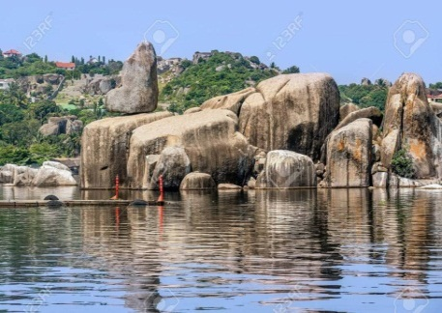

From the picture above, you are required to identify one object under each form

|  |  |
| --- | --- |
| Object | Form |
|  |  |
|  |  |
|  |  |

(c)Is there any form missing? If yes, state that form and give one example under it.

(2½mark)

………………………………………………………………………………………………………………………………………………………………………………………………………………………………………………………………………

**END**